Spark Assignment-3(Healthcare Data Analysis) Documentation
Create GCS bucket and under that created Source and Archive folder
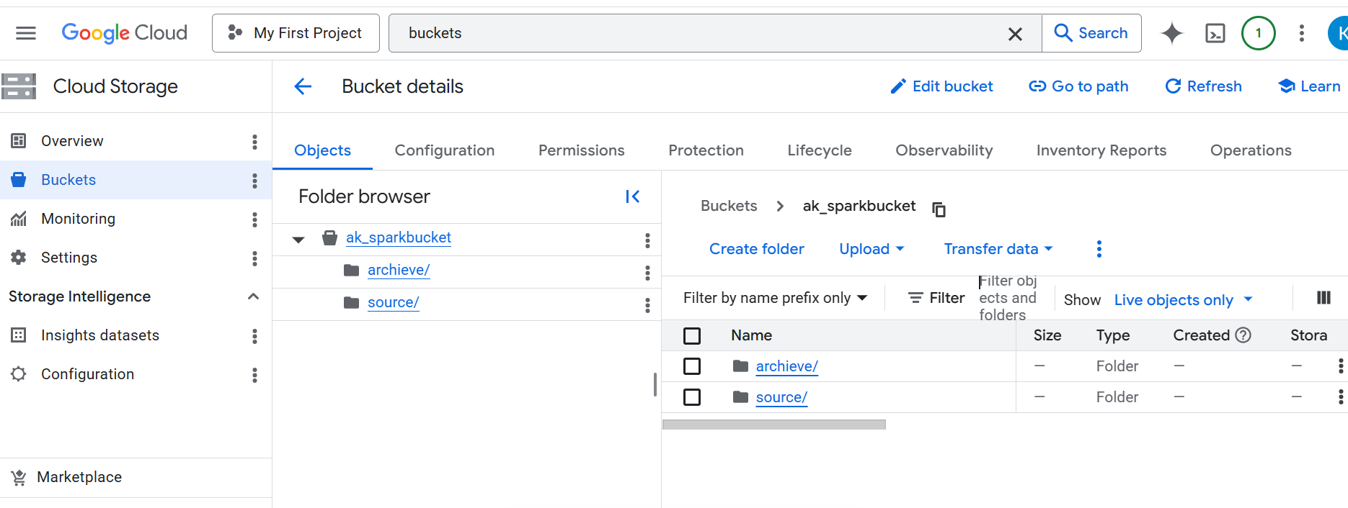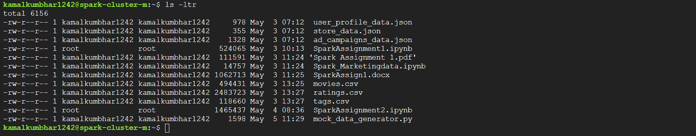
Move The mock_generator.py from Cluster VM location to GCP Storage
gcloud compute scp kamalkumbhar1242@spark-cluster-m:/home/kamalkumbhar1242/mock_data_generator.py .
Run the mock_generator.py on Google CLI
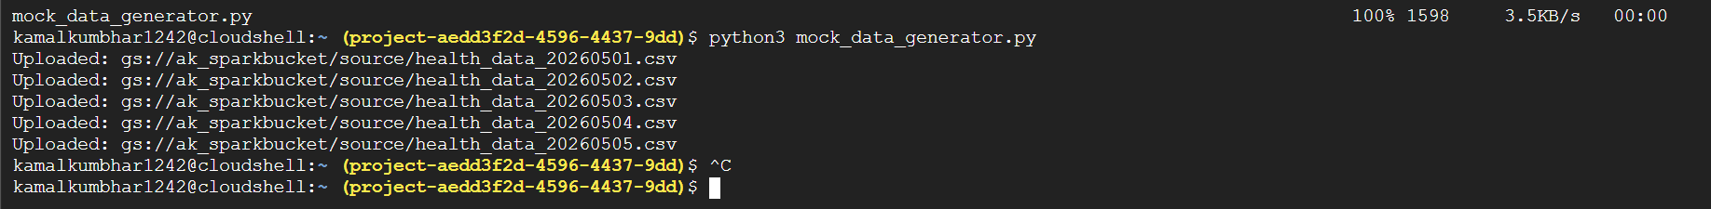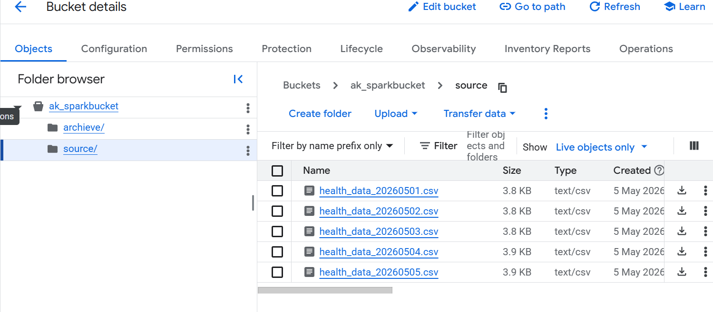
Create Spark Session

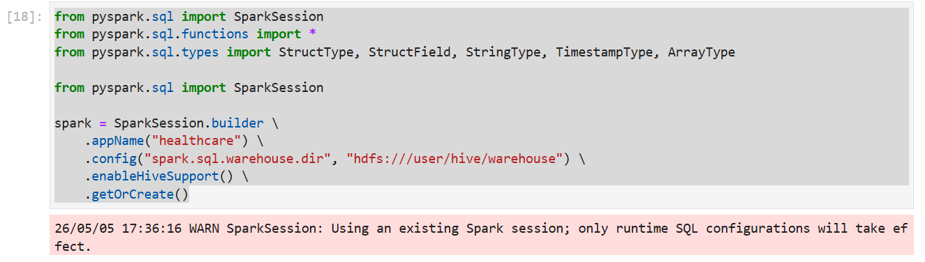
Connection with GCS bucket and Read all CSv file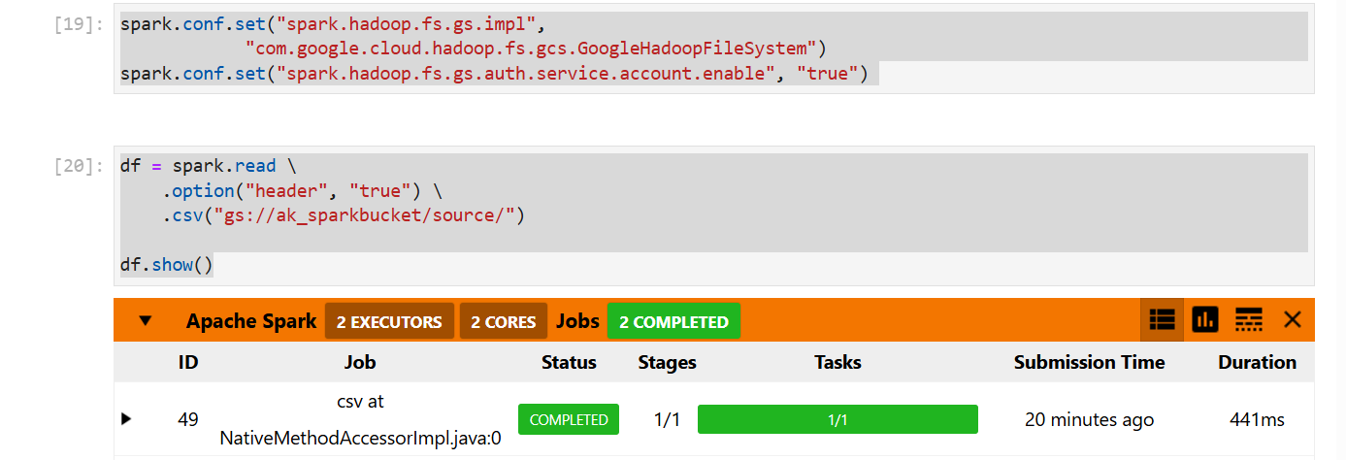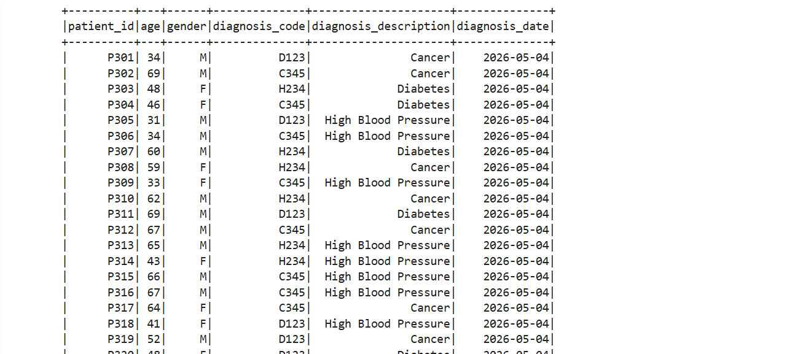
I made sure to include data quality checks so that the data is in the correct format.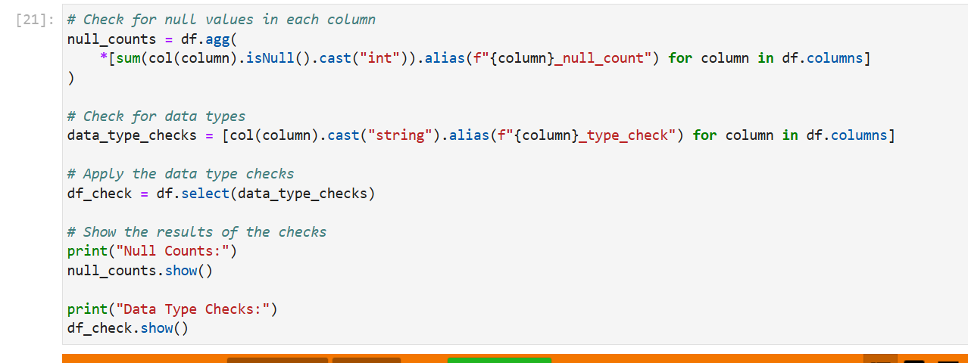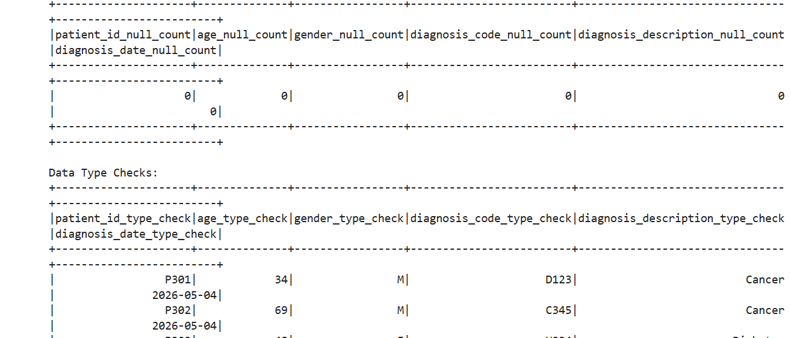
Disease Gender Ratio: Calculate the gender ratio for each disease. This will help in identifying if a particular disease is more prevalent in a particular gender. For example, for each diagnosis_code, you could calculate the ratio of male to female patients.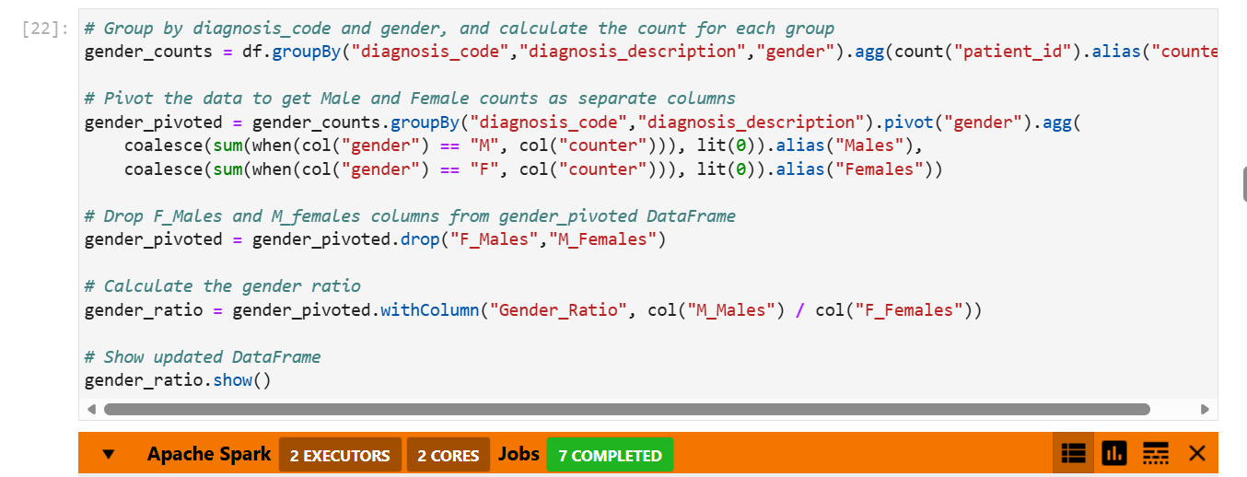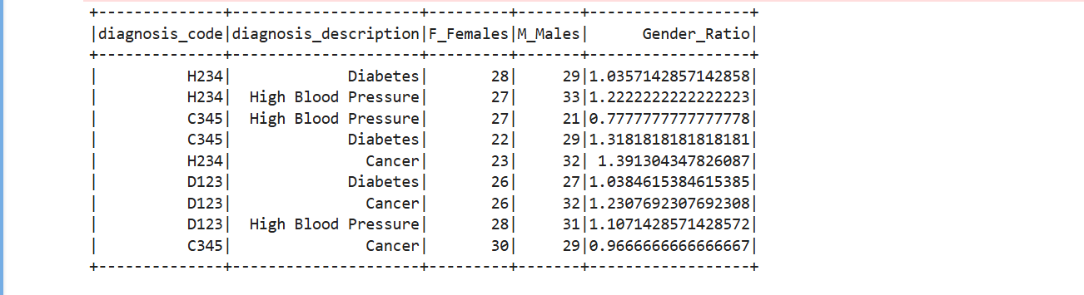
The transformed data should then be loaded into a HDFS table in upsert mode (Separate table for each type of transformation). This would involve creating stage and target tables, where the stage table will be used for the raw data and then upserted to the target table with transformed data. Think about the correct attributes which can work like a key for upsert operation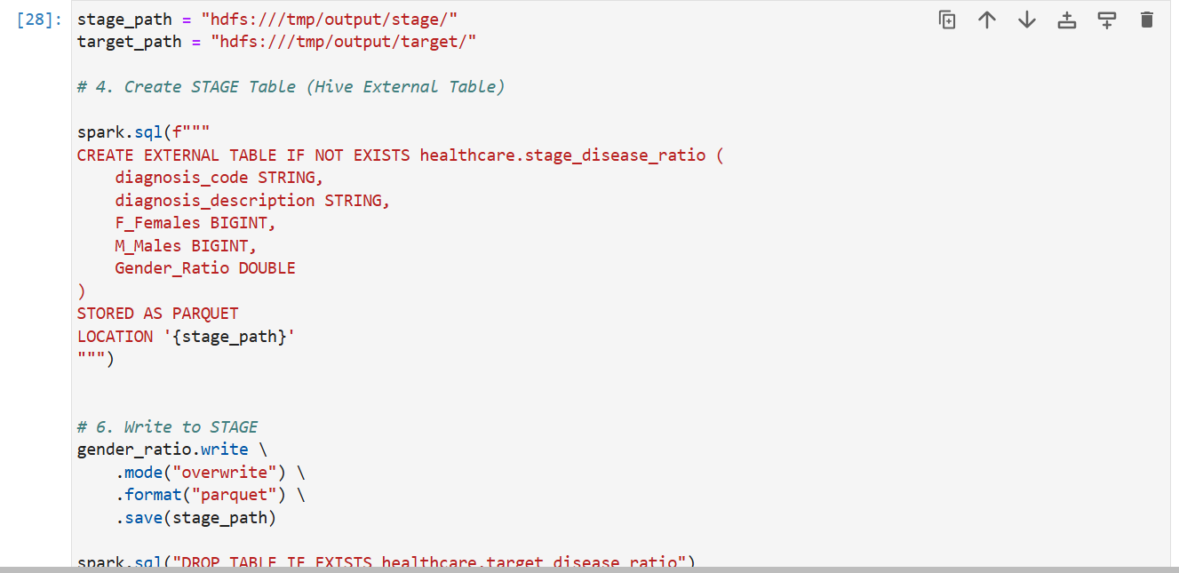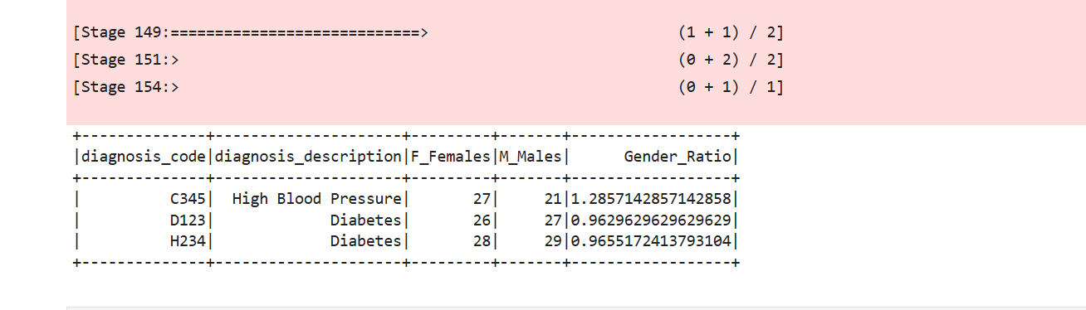
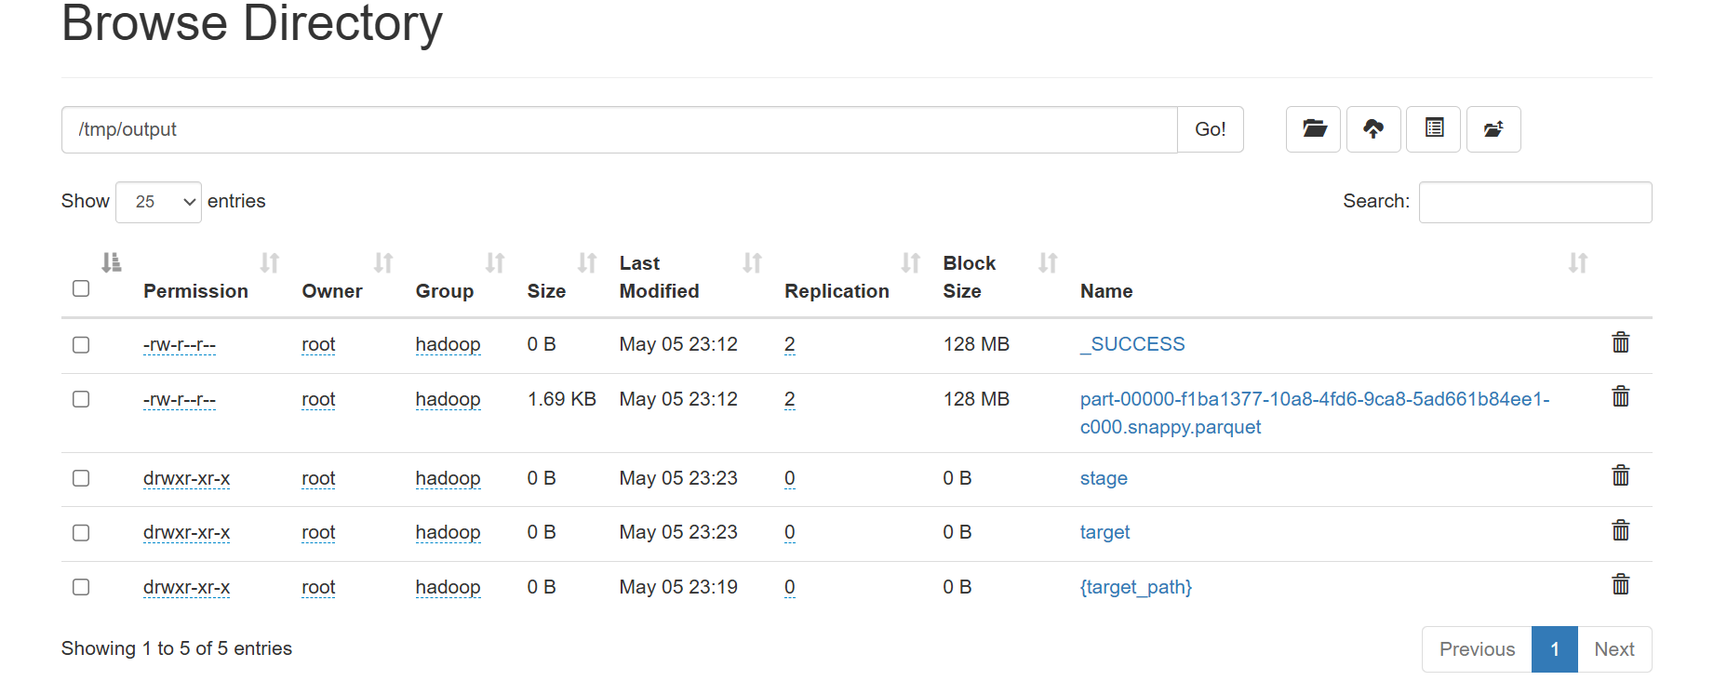 the input file should be moved to an archive folder in HDFS.